**桃園市 105 學年度「健康促進學校」佐證資料**

**一、活動紀錄：**

|  |  |  |
| --- | --- | --- |
| **活動照片** | | |
| **登革熱宣導海報** | **18052465_1723736384308602_1838263012_o.jpg** | **18072458_1723736407641933_240303054_n.jpg** |
| **活動照片** | | |
| **環境清潔海報** |  |  |
| **活動照片** | | |
| **健康蔬食講座** | **IMG_8918.JPG** | **IMG_8921.JPG** |
| **活動照片** | | |
| **生命教育講座** | **Photo4966.JPG** | **Photo4967.JPG** |
| **活動照片** | | |
| **親職家長講座** | **Photo4100.JPG** | **Photo4105.JPG** |
| **活動照片** | | |
| **老街溪整治講座** | **Photo4909.jpg** | **Photo4911.jpg** |
| **活動照片** | | |
| **生態導覽暨淨灘活動** | Photo3769.jpg | Photo3775.jpg |
| **活動照片** | | |
| **班際羽球賽** | Photo4122.jpg | Photo4121.jpg |
| **活動照片** | | |
| **班際拔河賽** | Photo4134.JPG | Photo4136.JPG |
| **活動照片** | | |
| **班際排球賽** | IMG_2804.JPG | IMG_2819.JPG |
| **活動照片** | | |
|  | IMG_9964.JPG | IMG_9919.JPG |

**桃園市立平鎮高級中學105學年第1學期\_平均身高統計圖**

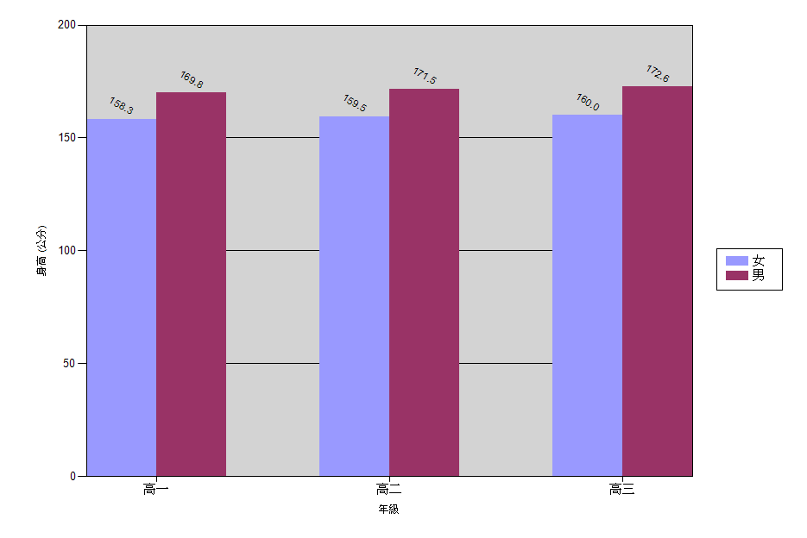

**桃園市立平鎮高級中學105學年第1學期\_體位統計(含比率)**

|  |  |  |  |  |  |  |  |
| --- | --- | --- | --- | --- | --- | --- | --- |
| 年級　/ 　性別 | | | 體位判讀 | | | | |
| 過輕 | 適中 | 過重 | 超重 | 合計 |
| 高一 | 男 | 人數 | 36 | 174 | 49 | 50 | 309 |
| 比率 | 11.7% | 56.3% | 15.9% | 16.2% | 100% |
| 女 | 人數 | 15 | 220 | 35 | 30 | 300 |
| 比率 | 5.% | 73.3% | 11.7% | 10.% | 100% |
| 小計 | 人數 | 51 | 394 | 84 | 80 | 609 |
| 比率 | 8.4% | 64.7% | 13.8% | 13.1% | 100% |
| 高二 | 男 | 人數 | 19 | 189 | 38 | 47 | 293 |
| 比率 | 6.5% | 64.5% | 13.% | 16.% | 100% |
| 女 | 人數 | 15 | 216 | 42 | 35 | 308 |
| 比率 | 4.9% | 70.1% | 13.6% | 11.4% | 100% |
| 小計 | 人數 | 34 | 405 | 80 | 82 | 601 |
| 比率 | 5.7% | 67.4% | 13.3% | 13.6% | 100% |
| 高三 | 男 | 人數 | 22 | 183 | 53 | 70 | 328 |
| 比率 | 6.7% | 55.8% | 16.2% | 21.3% | 100% |
| 女 | 人數 | 21 | 173 | 46 | 31 | 271 |
| 比率 | 7.7% | 63.8% | 17.% | 11.4% | 100% |
| 小計 | 人數 | 43 | 356 | 99 | 101 | 599 |
| 比率 | 7.2% | 59.4% | 16.5% | 16.9% | 100% |
| 總計 | | 人數 | 128 | 1155 | 263 | 263 | 1809 |
| 比率 | 7.1% | 承辦人:　　　　　　　　組長 :　　　　　　　　　 主任:　　　　　　　　 校長: | 14.5% | 14.5% | 100% |

**桃園市立平鎮高級中學105學年第1學期\_體位統計表**

|  |  |  |  |  |  |  |
| --- | --- | --- | --- | --- | --- | --- |
| 年級　/ 　性別 | | 體位判讀 | | | | |
| 過輕 | 適中 | 過重 | 超重 | 合計 |
| 高一 | 男 | 36 | 174 | 49 | 50 | 309 |
| 女 | 15 | 220 | 35 | 30 | 300 |
| 小計 | 51 | 394 | 84 | 80 | 609 |
| 高二 | 男 | 19 | 189 | 38 | 47 | 293 |
| 女 | 15 | 216 | 42 | 35 | 308 |
| 小計 | 34 | 405 | 80 | 82 | 601 |
| 高三 | 男 | 22 | 183 | 53 | 70 | 328 |
| 女 | 21 | 173 | 46 | 31 | 271 |
| 小計 | 43 | 356 | 99 | 101 | 599 |
| 總計 | | 128 | 1155 | 263 | 263 | 1809 |

**桃園市立平鎮高級中學105學年第1學期\_體位統計圖**

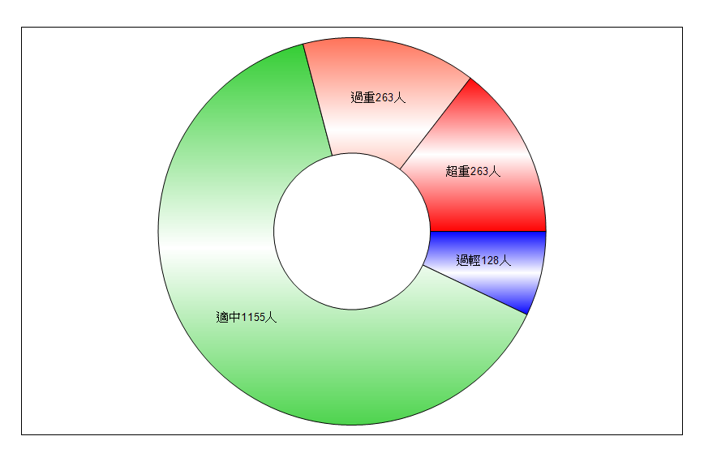

**桃園市立平鎮高級中學105學年第1學期\_視力統計圖**

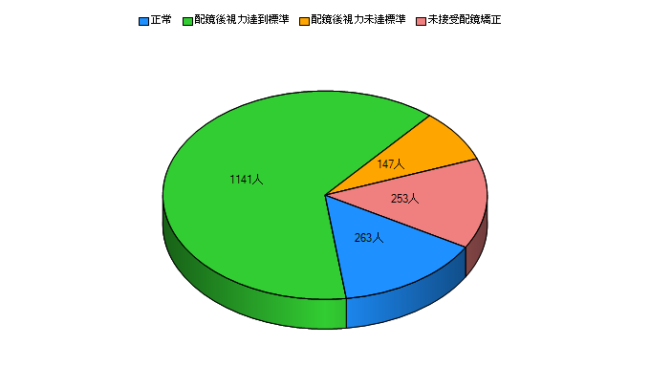

**桃園市立平鎮高級中學105學年第1學期\_視力統計表(含比率)**

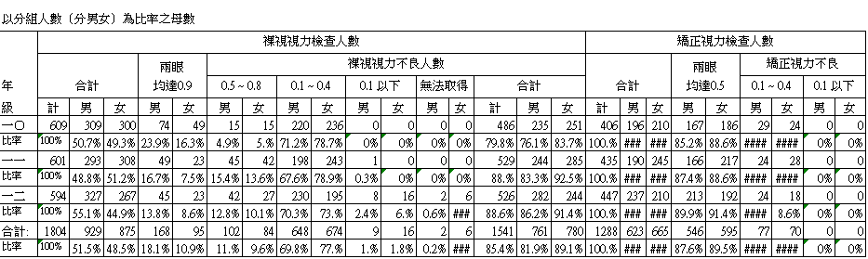

**桃園市立平鎮高級中學105學年第1學期\_裸視視力不良就醫率統計表(含戴鏡正常)**

|  |  |  |  |  |  |
| --- | --- | --- | --- | --- | --- |
|  | B：裸眼視力不良人數(含戴鏡視力正常)　Ａ：分母中有診斷的人數 | | | | |
|  |  |  |  |  |  |
|  | 年級 | 班 | 裸眼視力不良人數Ｂ | 就診人數Ａ | 就診率（A/B) |
|  | 高一 | 1 | 36 | 31 | 86.111% |
|  |  | 2 | 33 | 32 | 96.970% |
|  |  | 3 | 29 | 29 | 100.000% |
|  |  | 4 | 36 | 33 | 91.667% |
|  |  | 5 | 34 | 32 | 94.118% |
|  |  | 6 | 33 | 32 | 96.970% |
|  |  | 7 | 36 | 33 | 91.667% |
|  |  | 8 | 35 | 30 | 85.714% |
|  |  | 9 | 35 | 31 | 88.571% |
|  |  | 10 | 30 | 28 | 93.333% |
|  |  | 11 | 32 | 28 | 87.500% |
|  |  | 12 | 37 | 36 | 97.297% |
|  |  | 13 | 32 | 28 | 87.500% |
|  |  | 14 | 30 | 25 | 83.333% |
|  |  | 15 | 13 | 10 | 76.923% |
|  |  | 16 | 5 | 3 | 60.000% |
|  | 高一年級小計 |  | 486 | 441 | 90.741% |
|  | 高二 | 1 | 32 | 32 | 100.000% |
|  |  | 2 | 32 | 31 | 96.875% |
|  |  | 3 | 31 | 31 | 100.000% |
|  |  | 4 | 31 | 31 | 100.000% |
|  |  | 5 | 34 | 34 | 100.000% |
|  |  | 6 | 36 | 35 | 97.222% |
|  |  | 7 | 44 | 42 | 95.455% |
|  |  | 8 | 45 | 37 | 82.222% |
|  |  | 9 | 35 | 33 | 94.286% |
|  |  | 10 | 37 | 37 | 100.000% |
|  |  | 11 | 42 | 42 | 100.000% |
|  |  | 12 | 41 | 35 | 85.366% |
|  |  | 13 | 35 | 34 | 97.143% |
|  |  | 14 | 29 | 29 | 100.000% |
|  |  | 15 | 18 | 18 | 100.000% |
|  |  | 16 | 7 | 7 | 100.000% |
|  | 高二年級小計 |  | 529 | 508 | 96.030% |
|  | 高三 | 1 | 36 | 33 | 91.667% |
|  |  | 2 | 37 | 37 | 100.000% |
|  |  | 3 | 39 | 38 | 97.436% |
|  |  | 4 | 34 | 34 | 100.000% |
|  |  | 5 | 38 | 37 | 97.368% |
|  |  | 6 | 36 | 36 | 100.000% |
|  |  | 7 | 44 | 44 | 100.000% |
|  |  | 8 | 42 | 42 | 100.000% |
|  |  | 9 | 40 | 40 | 100.000% |
|  |  | 10 | 34 | 34 | 100.000% |
|  |  | 11 | 32 | 32 | 100.000% |
|  |  | 12 | 32 | 32 | 100.000% |
|  |  | 13 | 37 | 37 | 100.000% |
|  |  | 14 | 26 | 26 | 100.000% |
|  |  | 15 | 11 | 11 | 100.000% |
|  |  | 16 | 8 | 8 | 100.000% |
|  | 高三年級小計 |  | 526 | 521 | 99.049% |
|  |  | 全校合計 | 1541 | 1470 | 95.393% |

**桃園市立平鎮高級中學105學年高一年級理學檢查結果暨矯治追蹤統計表**

|  |  |  |  |  |  |  |  |  |  |  |  |  |  |  |
| --- | --- | --- | --- | --- | --- | --- | --- | --- | --- | --- | --- | --- | --- | --- |
| 類別 | | | | | 男 | 女 | 合計 |  |  |  |  |  |  |  |
| 受檢學生總數 | | | | | 309 | 300 | 609 |  |  |  |  |  |  |  |
| 健檢無異狀學生數 | | | | | 1 | 6 | 7 |  |  |  |  |  |  |  |
| 科別 | |  | | --- | | 統計 | | 未實施人數 | | 檢查項目結果發現異狀 | | | | | | 複檢就醫矯治追蹤情形 | | | | |
|  | 男 | 女 | 男 | | 女 | | 合計＊ | | 複檢正常☆ | 複檢異常△ | 未就醫× | 就醫率 | 備註﹝及其他異常項目﹞ |
| 檢查名稱 | 人數 | 人數 | 人數 | % | 人數 | % | 人數 | % | 人數 | 人數 | 人數 | % |  |
| 眼科 | 辨色力異常 | 0 | 0 | 4 | 1.29% | 2 | 0.67% | 6 | 0.99% | 0 | 6 | 0 | 100.00% |  |
| 其他 | |  | | --- | | 0 | | 1 | 1 | |  | | --- | | 0.32% | | 2 | |  | | --- | | 0.67% | | 3 | 0.49% | 0 | 3 | 0 | 100.00% |  |
| 耳鼻喉 | 聽力異常 | 0 | 0 | 0 | 0.00% | 0 | 0.00% | 0 | 0.00% | 0 | 0 | 0 |  |  |
| 耳道畸型 | 0 | 0 | 0 | 0.00% | 0 | 0.00% | 0 | 0.00% | 0 | 0 | 0 |  |  |
| 耳膜破損 | 0 | 0 | 0 | 0.00% | 0 | 0.00% | 0 | 0.00% | 0 | 0 | 0 |  |  |
| 耵聹栓塞 | 0 | 0 | 2 | 0.65% | 2 | 0.67% | 4 | 0.66% | 0 | 4 | 0 | 100.00% |  |
| 扁桃腺腫大 | 0 | 0 | 2 | 0.65% | 1 | 0.33% | 3 | 0.49% | 0 | 3 | 0 | 100.00% |  |
| 其他 | 0 | 0 | 0 | 0.00% | 0 | 0.00% | 0 | 0.00% | 0 | 0 | 0 |  |  |
| 頭頸 | 斜頸 | 0 | 0 | 0 | 0.00% | 0 | 0.00% | 0 | 0.00% | 0 | 0 | 0 |  |  |
| 異常腫塊 | 0 | 0 | 0 | 0.00% | 0 | 0.00% | 0 | 0.00% | 0 | 0 | 0 |  |  |
| 其他 | 0 | 0 | 0 | 0.00% | 0 | 0.00% | 0 | 0.00% | 0 | 0 | 0 |  |  |
| 胸部 | 心肺疾病 | 0 | 0 | 2 | 0.65% | 1 | 0.33% | 3 | 0.49% | 0 | 3 | 0 | 100.00% |  |
| 胸廓異常 | 0 | 0 | 0 | 0.00% | 0 | 0.00% | 0 | 0.00% | 0 | 0 | 0 |  |  |
| 其他 | 0 | 0 | 0 | 0.00% | 0 | 0.00% | 0 | 0.00% | 0 | 0 | 0 |  |  |
| 腹部 | 腹部異常腫大 | 0 | 0 | 0 | 0.00% | 0 | 0.00% | 0 | 0.00% | 0 | 0 | 0 |  |  |
| 其他 | 0 | 0 | 0 | 0.00% | 0 | 0.00% | 0 | 0.00% | 0 | 0 | 0 |  |  |
| 脊柱四肢 | 脊柱側彎 | 0 | 0 | 0 | 0.00% | 1 | 0.33% | 1 | 0.16% | 0 | 1 | 0 | 100.00% |  |
| 肢體畸形 | 0 | 0 | 0 | 0.00% | 0 | 0.00% | 0 | 0.00% | 0 | 0 | 0 |  |  |
| 蹲距困難 | 0 | |  | | --- | | 0 | | 27 | 8.74% | 24 | |  | | --- | | 8.00% | | 51 | 8.37% | 0 | 48 | 3 | 94.12% |  |
| |  | | --- | | 其他 | | 0 | 0 | 0 | 0.00% | 0 | 0.00% | 0 | 0.00% | 0 | 0 | 0 |  |  |
| 泌尿生殖 | 包皮異常 | 3 | 0 | 225 | 73.53% | 0 | 0.00% | 225 | 37.13% | 4 | 202 | 19 | 91.56% |  |
| 精索靜脈曲張 | 3 | 0 | 17 | 5.56% | 0 | 0.00% | 17 | 2.81% | 0 | 17 | 0 | 100.00% |  |
| 其他 | 0 | 0 | 0 | 0.00% | 0 | 0.00% | 0 | 0.00% | 0 | 0 | 0 |  |  |
| 皮膚 | 癬 | 0 | 0 | 2 | 0.65% | 0 | 0.00% | 2 | 0.33% | 0 | 2 | 0 | 100.00% |  |
| 疥瘡 | 0 | 0 | 0 | 0.00% | 0 | 0.00% | 0 | 0.00% | 0 | 0 | 0 |  |  |
| 疣 | 0 | 0 | 0 | 0.00% | 0 | 0.00% | 0 | 0.00% | 0 | 0 | 0 |  |  |
| 異位性皮膚炎 | 0 | 0 | 1 | 0.32% | 1 | 0.33% | 2 | 0.33% | 0 | 2 | 0 | 100.00% |  |
| 溼疹 | 0 | 0 | 0 | 0.00% | 0 | 0.00% | 0 | 0.00% | 0 | 0 | 0 |  |  |
| 其他 | 0 | 0 | 1 | 0.32% | 2 | 0.67% | 3 | 0.49% | 0 | 3 | 0 | 100.00% |  |
| 牙科 | 未治療齲齒 | 1 | 0 | 202 | 65.58% | 205 | 68.33% | 407 | 66.94% | 2 | 367 | 38 | 90.66% |  |
| 已治療齲齒 | 0 | 0 | 106 | 34.30% | 95 | 31.67% | 201 | 33.00% |  | | | |  |
| 上顎恆牙第一大臼齒齲齒經驗 | 0 | 0 | 61 | 19.74% | 88 | 29.33% | 149 | 24.47% |  |
| 下顎恆牙第一大臼齒齲齒經驗 | 0 | 1 | 54 | 17.48% | 56 | 18.73% | 110 | 18.09% |  |
| 恆牙臼齒窩溝封填 | 0 | 1 | 0 | 0.00% | 0 | 0.00% | 0 | 0.00% |  |
| 口腔衛生不良 | 0 | 0 | 0 | 0.00% | 0 | 0.00% | 0 | 0.00% | 0 | 0 | 0 |  |  |
| 牙結石 | 1 | 0 | 205 | 66.56% | 140 | 46.67% | 345 | 56.74% | 0 | 318 | 27 | 92.17% |  |
| 咬合不正 | 0 | 0 | 3 | 0.97% | 2 | 0.67% | 5 | 0.82% | 0 | 5 | 0 | 100.00% |  |
| 口腔黏膜異常 | 0 | 0 | 0 | 0.00% | 0 | 0.00% | 0 | 0.00% | 0 | 0 | 0 |  |  |
| 其他 | 0 | 0 | 203 | 65.70% | 206 | 68.67% | 409 | 67.16% | 3 | 370 | 36 | 91.20% |  |
| 血壓判讀 | | 0 | 0 | 31 | 10.03% | 23 | 7.67% | 54 | 8.87% | 4 | 48 | 2 | 96.30% |  |
| 蟯蟲陽性 | | 0 | 0 | 0 | 0.00% | 0 | 0.00% | 0 | 0.00% | 0 | 0 | 0 |  |  |
|  | |  |  |  |  |  |  |  |  |  |  |  |  |  |
| 尿液篩檢 | | 0 | 0 | 0 | 0.00% | 0 | 0.00% | 0 | 0.00% | 0 | 0 | 0 |  |  |
|  |  |  |  |  |  |  |  |  |  |  |  |  |  |  |
| 製表人: 體衛組長: 學務主任: 校長 : 填表日期 年 月 日 | | | | | | | | | | | | | | |
| 說明： |  |  |  |  |  |  |  |  |  |  |  |  |  |  |
| 一、本表置於教育部網站體育司業務介紹之學校衛生項之健康檢查，請依「班級健康檢查結果暨矯治追蹤名冊」一、四、七年級分開統計。 | | | | | | | | | | | | | | |
| 二、異狀百分比=異狀人數÷受檢總人數，就醫率=﹝☆+○﹞÷﹝＊﹞ | | | | | | | | | | | | | | |
| 三、健康檢查於上學期執行者本表於二月底前上傳完成,並製作一式兩份，一份留存學校備查，一份送教育局體健課。 | | | | | | | | | | | | | | |
| 四、視力不良是指E字視力檢查表篩檢值任一眼低於0.8以下(含0.8), 近視、遠視、散光、斜弱視的判讀是指經眼科醫師診斷後的判讀結果 ; | | | | | | | | | | | | | | |
| 「辨色力異常」指以色盲檢查卡檢出辨色異狀人數。 | | | | | | | | | | | | | |  |
| 五、蟯蟲陽性的統計，請填寫與健康檢查同學期之第一次蟯蟲檢查陽性的人數。 | | | | | | | |  |  |  |  |  |  |  |
| 六 、近視﹑遠視﹑散光為視力不良分類診斷,故不計算矯治率。 | | | | | |  |  |  |  |  |  |  |  |  |

|  |  |  |  |  |  |
| --- | --- | --- | --- | --- | --- |
| 104學年度 市立平鎮高中 資料平均 | | | | | |
|  | 身高/體重  身體組成 | 坐姿體前彎 | 立定跳遠 | 仰臥起坐 | 心肺適能 |
| 男(930) | 171.56公分/64.56公斤/21.90 | 30.14 | 216.73 | 45.37 | 479.83 |
| 女(906) | 159.22公分/53.21公斤/20.96 | 35.96 | 161.70 | 34.32 | 262.14 |
| 全(1836) | 165.47公分/58.96公斤/21.43 | 33.01 | 189.83 | 39.93 | 372.86 |

|  |  |  |  |  |  |  |
| --- | --- | --- | --- | --- | --- | --- |
| 104學年度 市立平鎮高中 全校學生體適能獎章狀態 | | | | | | |
|  | 金牌 | 銀牌 | 銅牌 | 中等 | 待加強 | 無法評等 |
| 男(984) | 49 | 70 | 323 | 266 | 189 | 33 |
| 女(925) | 39 | 68 | 306 | 283 | 156 | 54 |
| 全(1909) | 88 | 138 | 629 | 549 | 345 | 87 |

