
Listening Test
Week One: Unit 1~2 (Aug. 1-3)

Part A 20% 每題 10 分 曲目17
Look at the picture below. You will hear two questions and four possible answers, A to D. Write down the letter for the best answer (A, B, C or D).
Questions 1-2
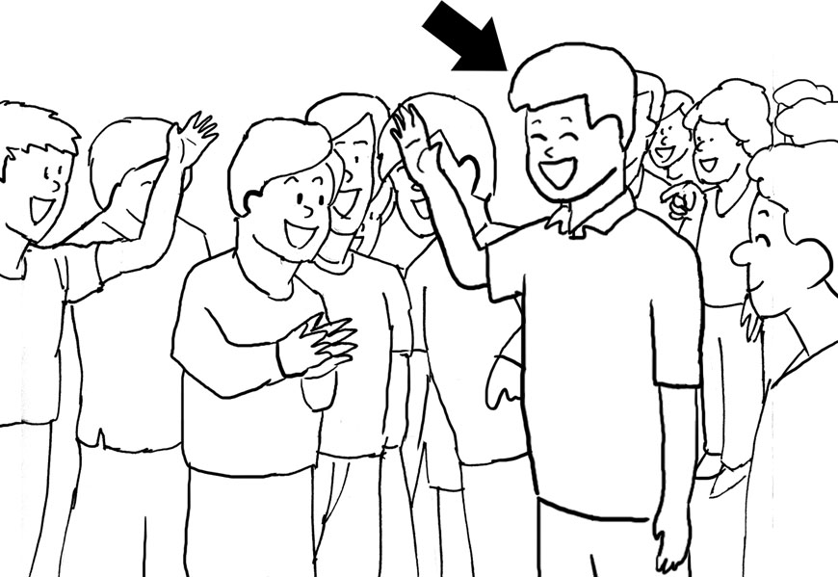

B 1. What can be said of the boy in the middle? (Unit 1)
(A) He is with many children.
(B) He enjoys great popularity.
(C) He prefers to be alone.
(D) He doesn’t get any attention.
C 2. What else might be true of the boy? (Unit 1)
(A) He has only one friend.
(B) He is very lonely.
(C) He gets along with everyone.
(D) He has a lot of enemies.

Part B 20% 每題 5 分 曲目18

In part B, you will hear one or more questions or statements. Choose the best response or reply.
D 3. What is your point of view? (Unit 1)
(A) You want me to point at that view?
(B) My office has a great view.
(C) I don’t want to point at people.
(D) You really want my opinion?
C 4. Are you aware of the problem? (Unit 1)
(A) Yes, I have never heard of it.
(B) No, this is serious.
(C) Yes, I know about it.
(D) No, I caused the problem.
B 5. I’m feeling a lot of sorrow right now. (Unit 2)
(A) Get some sleep if you are tired.
(B) Why are you so sad?
(C) You shouldn’t be so angry.
(D) It’s good to know you’re feeling better.
A 6. I just completed my first novel. (Unit 2)
(A) I didn’t know you were writing a book.
(B) Where can I buy the CD?
(C) It must be a fun class activity.
(D) Who ended up winning the game?
Part C 36% 每題 9 分 曲目19
In part C, you will hear some short conversations between a man and a woman, and then a question following each conversation. Choose the best answer to that question.
Weekly Quiz Listening Test, Answer Key Week One: Unit 1~2 (Aug. 1-3)

A卷

A 7. W: I’m really looking forward to reading your next article.
M: It will be published next week.
Q: What is true of the article? (Unit 1)
(A) It will be available to read next week.
(B) It will be written next week.
(C) People can read it until next week.
(D) People will forget about it next week.
C 8. M: What did you think of the movie?
W: It was very entertaining.
Q: What is likely true of the woman? (Unit 1)
(A) She’s never heard of the movie.
(B) She missed the movie.
(C) She enjoyed the movie.
(D) She hated the movie.
C 9. W: What are you listening to?
M: These are some songs I just wrote and recorded.
W: Oh, are you going to put out an album?
M: I don’t plan on releasing one.
Q: What do we know about the man? (Unit 1)
(A) His songs are at the top of the charts.
(B) He doesn’t write his own songs.
(C) He won’t make his songs available.
(D) His album will be out soon.
D 10. W: What’s that book?
M: It’s a new science fiction story.
W: How is it?
M: I’ve only read one paragraph.
Q: What has the man read? (Unit 1)
(A) A chapter of a book.
(B) A whole book.
(C) A whole page of a book.
(D) A short section of one page.

Part D 24% 每題 8 分 曲目20
In part D, you will hear one passage and then some questions about it. Choose the best answers to those questions.
Johann Wolfgang von Goethe wrote his first book when he was just eight years old. Amazingly, the characters in the book communicate in five different languages. Goethe would grow up to become one of the most discussed authors, scientists, and philosophers of all time.
He is best known for his play, Faust, which is considered one of the greatest dramas of all time. It’s a play that everyone should read. (Unit 2)
C 11. What is true of Goethe’s first book?
(A) It has five chapters in it.
(B) It has five pages in it.
(C) It has five languages in it.
(D) It has five characters in it.
A 12. What do we know about Faust?
(A) People say it’s excellent.
(B) People say it could be better.
(C) People say it’s awful.
(D) People say it’s too long.
B 13. According to the article, Goethe is not which of the following?
(A) A philosopher.
(B) A photographer.
(C) A scientist.
(D) An author.

I. Vocabulary 30% 每題 5 分
Weekly Quiz Reading Test Week One: Unit 1~2 (Aug. 1-3)

A卷

A. governed | B. officer | C. comic
D. get away | E. aware of | F. released
G. author | H. diary | I. get along
G 1. Who is the ______ of that book? (Unit 2)
I 2. My dog doesn’t ______ with my cat. (Unit 1)
C 3. Most ______ books don’t take too long to read. (Unit 2)
E 4. Julie was not ______ the man who was following her. (Unit 1)
F 5. The movie will be ______ later this year. (Unit 2)
H 6. I write about my life in my ______. (Unit 1)
II. Cloze Test 30% 每題 6 分
Greg Heffley is an American junior high student. He is also the main 7 of the Diary of a Wimpy Kid book series. Greg has lots of problems. Girls at school are not interested in him at all. He’s also a poor student because he 8 too much time playing video games. Throughout the series, Greg makes lots of bad decisions. He often 9 for making these poor decisions too.
Diary of a Wimpy Kid books have become very popular. The first book was published in 2007. 10 then, five other Diary of a Wimpy Kid books have been published. Several movies based on the series have also been made. These books are useful for students who are trying to learn English. Everyday American English 11 in them. They’re a fun way to practice reading English. (Unit 1)
C 7. (A) captain (B) chapter
(C) character (D) carpenter
A 8. (A) spends (B) takes
(C) makes (D) offers
D 9. (A) gets the point (B) takes the charge
(C) gives the credit (D) pays the price
B 10. (A) Around (B) Since
(C) Through (D) During
C 11. (A) uses (B) used
(C) is used (D) was used

III. Translation 20% 每格 5 分
12. 我們該如何應付學校裡的壞小孩呢？
How are we going to deal with the bad kids at school? (Unit 1)
13. 我依然認為我能贏，所以我還沒有要放棄。
I still think I can win, so I’m not going to give up yet. (Unit 1)
IV. Reading Comprehension 20% 每題 10 分
Johann Wolfgang von Goethe is one of the greatest German writers ever. He is best known for writing the drama Faust. Faust is about a man who sells his soul in exchange for knowledge of all things.
Goethe started writing at a young age. He wrote his first novel when he was only eight years old. In this novel, the characters spoke to each other in five different languages.
Goethe did more than writing. He was also a successful scientist. Truly, he was a real genius. (Unit 2)
B 14. Which of the following best describes Faust?
(A) It’s about Germany.
(B) It’s a famous book.
(C) It has five characters.
(D) It’s about Goethe’s life.
D 15. Which of the following is true of Goethe?
(A) Faust was the first novel he wrote.
(B) He wrote about an eight-year-old boy.
(C) He could only speak German.
(D) He was also good at science.
Listening Test
Week Two: Unit 3~5 (Aug. 6-10)

Part A 20% 每題 10 分 曲目21
Look at the picture below. You will hear two questions and four possible answers, A to D. Write down the letter for the best answer (A, B, C or D).
Questions 1-2


D 1. What is true of the man’s shirt? (Unit 3)
(A) It has many pictures.
(B) It has a funny pattern.
(C) It has long sleeves.
(D) It has a collar.
B 2. Which of the following is NOT true? (Unit 5)
(A) He is at work.
(B) His computer should be shut down.
(C) His computer is in use.
(D) He is looking at the computer screen.

Part B 20% 每題 5 分 曲目22

In part B, you will hear one or more questions or statements. Choose the best response or reply.
C 3. You should show your mother some respect. (Unit 3)
(A) I’ll buy her one this afternoon.
(B) But I don’t owe her any money.
(C) I do admire her a lot.
(D) I’ll show her my homework later.
A 4. This drink combines apple juice with orange juice. (Unit 4)
(A) It will taste a little like both.
(B) Good, I don’t like either one.
(C) Then I pick orange juice.
(D) You want to drink apple juice, or orange juice?
D 5. That was a very dramatic performance. (Unit 4)
(A) Yeah, it was totally boring.
(B) Yes, it was really funny.
(C) Yeah, it was too scary!
(D) Yes, it was quite impressive.
B 6. I can play several different instruments. (Unit 4)
(A) What sports are you good at?
(B) Oh, is the guitar one of them?
(C) I didn’t know you play video games.
(D) You shouldn’t play tricks on people.

Part C 36% 每題 9 分 曲目23
In part C, you will hear some short conversations between a man and a woman, and then a question following each conversation. Choose the best answer to that question.
Weekly Quiz Listening Test, Answer Key Week Two: Unit 3~5 (Aug.6-10)

A卷

B 7. W: Is that story true?
M: I just made it up.
Q: What does the man say about the story? (Unit 4)
(A) It’s not a lie.
(B) It’s not true.
(C) It’s mostly true.
(D) It’s a friend’s story.
C 8. M: What are your plans this weekend?
W: I’m hosting a party.
Q: What does the woman say about the party? (Unit 4)
(A) It will be canceled.
(B) She would love to go.
(C) It may be at her place.
(D) She will not be there.
A 9. W: This apartment looks pretty good.
M: I don’t think we should rent it.
W: Why not?
M: It’s tiny!
Q: What does the man say about the apartment? (Unit 5)
(A) It’s very small.
(B) It’s not safe.
(C) It’s a bit dirty.
(D) It’s too big.
D 10. W: I want to go swimming.
M: I don’t think it’s safe to swim here.
W: It’s safe. Please can I go?
M: OK, but stay close to the shore.
Q: Where does the man tell the woman to stay close to? (Unit 5)
(A) The deep part of the water.
(B) A large rock by the water.
(C) The other people in the water.
(D) The land on the edge of the water.

Part D 24% 每題 8 分 曲目24
In part D, you will hear one passage and then some questions about it. Choose the best answers to those questions.
Have you seen Rock of Ages yet? The movie is based on a hit Broadway musical. It is about a couple of young people who come to L.A. trying to become rock stars. When they get to L.A., some people take them under their wings. But will they have a chance to record a hit song? Go and see the movie to find out. (Unit 5)
C 11. What happens when the two young people go to L.A.?
(A) They get lost and feel afraid.
(B) They lose all their money.
(C) Some people take care of them.
(D) Some friends refuse to help them.
D 12. What is true of the movie?
(A) It has little to do with music.
(B) It is an introduction to a concert.
(C) It is about music history.
(D) The idea for it came from a musical.
A 13. What is the main purpose of this passage?
(A) To introduce a movie plot.
(B) To discuss the city of L.A.
(C) To talk about Broadway hits.
(D) To explain what makes a hit song.

I. Vocabulary 30% 每題 5 分
Weekly Quiz Reading Test Week Two: Unit 3~5 (Aug. 6-10)

A卷

A. tradition | B. respect | C. hits
D. shut | E. gaps | F. fields
G. shore | H. drop | I. result
F 1. The farmer is working in the ______. (Unit 3)
C 2. This radio station plays lots of ______. (Unit 5)
A 3. The town has a ______ of having a big party every New Year’s Day. (Unit 3)
B 4. Mark has a lot of ______ for his hardworking father. (Unit 3)
D 5. I let the dog out and ______ the door behind it. (Unit 5)
G 6. We sat by the ______ and watched the waves. (Unit 4)
II. Cloze Test 30% 每題 6 分
The Edinburgh Festival is held every year in Edinburgh, Scotland. It 7 seven different festivals, including movie, book, and music festivals. There are so many things to do. It’s hard to decide what to do first.
One of the most 8 festivals is the Edinburgh Fringe Festival. People from all over the world go to see it. 9 from dramatic plays to dance shows take place there. Most of the plays and shows are free, so grab as many tickets as you can.
In one play, the actors do not have anything planned. 10 , they get ideas from the audience and make up a funny story. When this play is over, you can go watch a huge army band play 11 Edinburgh Castle. It’s an experience you will never forget! (Unit 4)
D 7. (A) interrupts (B) exchanges
(C) recovers (D) combines
C 8. (A) hateful (B) confused
(C) famous (D) delicious
A 9. (A) Everything (B) One thing
(C) Something (D) Nothing
B 10. (A) Since (B) Instead
(C) First (D) Besides
D 11. (A) in need of (B) in favor of
(C) in search of (D) in front of

III. Translation 20% 每格 5 分
12. 除了那張沉重的桌子以外，我們可以將所有東西搬到屋外。
Aside from the heavy table, we were able to move everything out of the house. (Unit 3)
13. 這個電玩遊戲好玩又有趣，讓我完全沉迷在其中。
The video game was so fun and interesting that I lost myself in it. (Unit 4)
IV. Reading Comprehension 20% 每題 10 分
Rock of Ages is a movie that follows two young singers named Drew and Sherrie. They move to Los Angeles because they want to become rock stars. When they first meet each other, they fall in love right away. But life in Los Angeles is not easy. Sherrie has to work as a waitress at a restaurant. Later, she meets someone that works at a music club. This might be her chance to become a rock star! But, a group led by the mayor’s wife is trying to close down some music clubs. Will Sherrie and Drew be able to stop them? (Unit 5)
C 14. What happens to Sherrie and Drew after they move to Los Angeles?
(A) They find some nice jobs.
(B) They meet several rock stars.
(C) They have a difficult time.
(D) They close down a music club.
A 15. Which of the following is NOT true?
(A) Sherrie is friends with the mayor’s wife.
(B) Drew falls in love with Sherrie.
(C) Drew wants to become a rock star.
(D) Sherrie has to work at a restaurant.
Listening Test
Week Three: Unit 6~8 (Aug. 13-17)

Part A 20% 每題10分 曲目25
Look at the picture below. You will hear two questions and four possible answers, A to D. Write down the letter for the best answer (A, B, C or D).
Questions 1-2
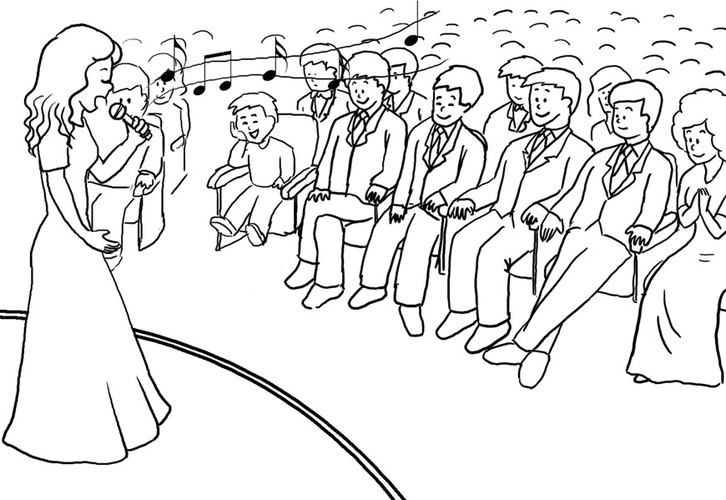

A 1. What can we say about the woman on the stage? (Unit 7)
(A) She is having a successful performance.
(B) She is sitting on a chair and playing a guitar.
(C) She isn’t being well received by the crowd.
(D) She is dancing with another man.
C 2. What is NOT true about the woman? (Unit 7)
(A) She is singing.
(B) She is popular.
(C) She is gathering flowers.
(D) She is holding a microphone.

Part B 20% 每題5分 曲目26

In part B, you will hear one or more questions or statements. Choose the best response or reply.
A 3. His hand was stuck in the fence. (Unit 8)
(A) How did he free his hand?
(B) He should have painted it white.
(C) Why did he build a fence?
(D) He must have been really lucky.
C 4. Can you light these candles? (Unit 7)
(A) Sure, I can take them outside.
(B) No, I can’t sell them now.
(C) Okay. I have a match to do it.
(D) No, I didn’t make a wish.
A 5. The two countries fought for decades. (Unit 6)
(A) I heard they fought for 25 years.
(B) That’s not true, their war lasted 20 years.
(C) They had a war for 12 weeks.
(D) Sure, they’ve been friends forever.
B 6. My grandpa just donated to my college fund. (Unit 6)
(A) Why did he want to go to college?
(B) You are so lucky!
(C) I don’t think he wanted you to go to college.
(D) How much money did he take from you?
Part C 36% 每題9分 曲目27
In part C, you will hear some short conversations between a man and a woman, and then a question following each conversation. Choose the best answer to that question.
Weekly Quiz Listening Test, Answer Key Week Three: Unit 6~8 (Aug. 13-17)

A卷

A 7. W: What support do your parents provide?
M: The usual kind of help.
Q: What does the woman want to know? (Unit 7)
(A) What his parents give him.
(B) Where his parents went to college.
(C) What his parents do for a living.
(D) How much time he spends with his parents.
D 8. M: Do you often have nightmares about a day at school that never ends?
W: No, but I do have many with monsters.
Q: What are these two people talking about? (Unit 8)
(A) Their favorite dreams to have at night.
(B) The grades they currently have in school.
(C) What they don’t like about their school.
(D) What kind of bad dreams they have.
A 9. W: We have a new student in class today.
M: Really? What is he like?
W: He seems clever and kind.
M: That’s good. I can’t wait to meet him.
Q: What do we know about the new boy? (Unit 7)
(A) He is smart and nice.
(B) He is boring and mean.
(C) He is dumb and ugly.
(D) He is strong and handsome.
B 10. W: Happy New Year!
M: Happy New Year to you, too.
W: What’s your main goal for the New Year?
M: I would like to start studying English again. How about yours?
Q: What are they talking about? (Unit 7)
(A) How many points they will score next year.
(B) Their most important ambition for the year.
(C) Where they would like to live next year.
(D) What they did last year.

Part D 24% 每題8分 曲目28
In part D, you will hear one passage and then some questions about it. Choose the best answers to those questions.
Street art is a popular form of art that uses city landscapes. The art often challenges some kind of government policy. These artists come from countries all over the globe, like England, France, and the U.S. The best-known artist is Banksy. He’s kept his identity unknown during all these years of activity. Sadly, some of his art has been destroyed in recent years. (Unit 6)
D 11. What is said about Banksy?
(A) He created the street art museum.
(B) He is hated by the community.
(C) He is incredibly good-looking.
(D) He is perhaps the most popular street artist.
A 12. Where can street art be found?
(A) All over the world.
(B) England.
(C) France.
(D) The U.S.
B 13. What is street art?
(A) Works of art in museums.
(B) Works of art in public places.
(C) Works of art in book stores.
(D) Works of art sold in the supermarket.

I. Vocabulary 30% 每題 5 分
Weekly Quiz Reading Test Week Three: Unit 6~8 (Aug. 13-17)

A卷

A. lung | B. print | C. active
D. attention | E. identity | F. decades
G. flush | H. policy | I. unusual
C 1. The students were ______ outside playing games during the break after lunch. (Unit 6)
G 2. Her toilet wouldn’t ______, so she asked her friend to repair it. (Unit 7)
H 3. The school has a strict “no cell phone” p______ for both students and teachers. (Unit 6)
E 4. Superheroes tend to keep their ______ secret, so no one knows who they are. (Unit 6)
A 5. Smoking can make it difficult to breathe and can cause serious ______ damage. (Unit 7)
F 6. They’ve been married for twenty years – that’s two ______! (Unit 6)
II. Cloze Test 30% 每題 6 分
Have you ever considered which country Häagen-Dazs ice cream is from? America is the answer. The 7 product was given a Danish-sounding name, though it actually doesn’t mean a thing in Danish.
Can you guess why certain turtles can 8 oxygen through their butts? The small bags 9 in their bottom can provide turtles with much needed air. These turtles are able to receive half of their air 10 this way. Don’t you wish you could breathe that way too?
Finally, is it possible to make a flame with a fart? The answer is yes. You can light the gas 11 fire. But I wouldn’t recommend it, as you can easily burn yourself. (Unit 7)
C 7. (A) scary (B) slim
(C) dairy (D) dizzy
D 8. (A) fasten (B) settle
(C) handle (D) gather
A 9. (A) located (B) accepted
(C) locating (D) accepting
C 10. (A) basket (B) number
(C) supply (D) project
B 11. (A) in (B) on
(C) by (D) at

III. Translation 20% 每格 4 分
12. 學生們被要求想出環保計劃來改善環境。(Unit 7)
Students were asked to come up with “green ideas” to help improve the environment.
13. 每個學生對不同的地球問題表示關切。(Unit 6)
Each student showed concern about a different part of the Earth’s troubles.
IV. Reading Comprehension 20% 每題 10 分
When street art started in the 1970s, there was little to indicate that it would become a global concept. Today, new artists are often using walls and city landscapes to display their art works. In the U.K., Banksy is known for creating images questioning public policy. He has also done things crazy enough to be published in the newspaper. One act had him place one of his art pieces in the Louvre Museum in Paris, France. Still, there are those who simply call street artists destroyers of public property, but the truth is the street artists create something for people to think about. (Unit 8)
B 14. What do we know about street art?
(A) It was created by Banksy.
(B) It can be seen around the world.
(C) It started in the U.K.
(D) It can only be found in the U.K.
A 15. Which of the following is NOT true?
(A) Street artists live in the Louvre Museum.
(B) Some people think street art is bad.
(C) Banksy is a British street artist.
(D) Street art has been around for about four decades.

Listening Test
Week Four: Unit 9~12 (Aug. 20-30)

Part A 20% 每題 10 分 曲目29
Look at the picture below. You will hear two questions and four possible answers, A to D. Write down the letter for the best answer (A, B, C or D).
Questions 1-2
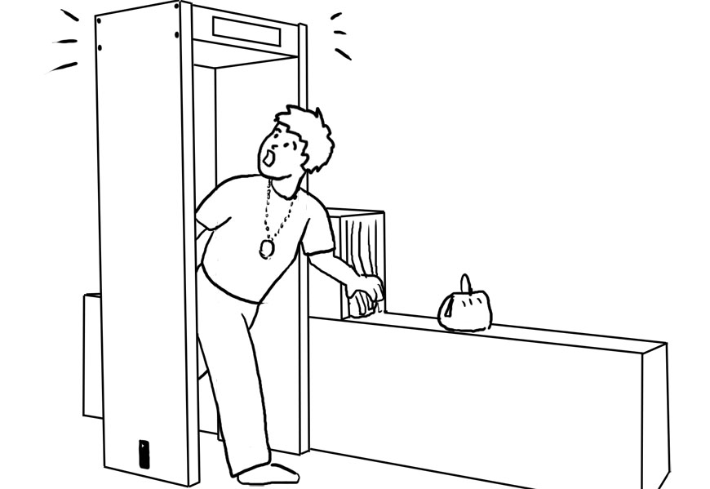

B 1. What has happened in the picture? (Unit 9)
(A) The man has won a prize.
(B) The alarm has gone off.
(C) The flight has been cancelled.
(D) The bags have been rejected.
C 2. What is likely true of the man? (Unit 9)
(A) He must leave the airport now.
(B) He can get on the plane right away.
(C) He’s wearing something made of metal.
(D) He is carrying something allowed.

Part B 20% 每題 5 分 曲目30

In part B, you will hear one or more questions or statements. Choose the best response or reply.
D 3. Our truck is over the height limit for the garage. (Unit 9)
(A) Then it’s lucky our truck isn’t very big.
(B) Then it’s safe to drive into the garage.
(C) Then we’d better move the garage.
(D) Then we’d better not drive into it.
C 4. Please instruct Bobby on how to do this assignment. (Unit 10)
(A) OK, I’ll give him the assignment.
(B) Yes, I will keep it away from him.
(C) OK, I’ll tell him how to do it.
(D) Sure, I’ll ask him for help.
B 5. That movie was absolutely excellent. (Unit 10)
(A) I also thought it was terrible.
(B) I really enjoyed it, too.
(C) I didn’t expect that it would be so boring.
(D) We should ask for our money back.
A 6. Do you keep a journal? (Unit 12)
(A) Yes, I write down my thoughts every day.
(B) Yes, I own several new books.
(C) Yes, I have two cats and two dogs.
(D) Yes, I read the newspaper every day.
Part C 36% 每題 9 分 曲目31
In part C, you will hear some short conversations between a man and a woman, and then a question following each conversation. Choose the best answer to that question.
Weekly Quiz Listening Test, Answer Key Week Four: Unit 9~12 (Aug. 20-30)

A卷

A 7. W: Did you see the car accident?
M: Yes, it happened suddenly.
Q: What does the man say about the accident? (Unit 10)
(A) It happened quickly and unexpectedly.
(B) He expected it to happen.
(C) It was a wonderful experience.
(D) It happens all the time.
C 8. M: Are you sure you want to pay for dinner?
W: I insist.
Q: What is true of the woman? (Unit 10)
(A) She refuses to pay for dinner.
(B) She wants the man to pay for dinner.
(C) She really wants to pay for dinner.
(D) She can’t afford to pay for dinner.
B 9. W: This lake is so beautiful.
M: I know. The water is so calm.
W: Do you think the water is warm?
M: I’m going to go for a dip and find out.
Q: What will the man do next? (Unit 12)
(A) Take a boat trip.
(B) Go for a swim.
(C) Drink the water.
(D) Dry himself off.
D 10. W: Excuse me, I seem to be lost.
M: Where are you trying to get to?
W: I need to go to the bank.
M: Oh, it’s on the opposite side of town.
Q: Where is the bank? (Unit 12)
(A) On the same street.
(B) Right in front of the woman.
(C) In another town.
(D) On the other side of town.

Part D 24% 每題 8 分 曲目32
In part D, you will hear one passage and then some questions about it. Choose the best answers to those questions.
Jamie Oliver has a new show called Jamie Cooks Summer. On the program, he shows us how to cook delicious food outdoors. One dish he makes is bucket smoked fish. The key is to use a cloth to trap the smoke. This gives the fish its flavor. Tune in to the show for more great cooking tips. (Unit 11)
C 11. What gives the fish its flavor?
(A) The bucket.
(B) The outdoor air.
(C) The smoke.
(D) The cloth.
A 12. According to the article, what does the cloth do?
(A) It keeps the smoke from escaping.
(B) It is useful for cleaning the dishes.
(C) It helps get rid of the smoke.
(D) It helps clean the fish.
B 13. What is the purpose of the show?
(A) To teach people about buying fresh fish.
(B) To teach people how to cook outside.
(C) To show how to hunt animals outdoors.
(D) To show how to clean a fish.
I. Vocabulary 30% 每題 5 分
Weekly Quiz Reading Test Week Four: Unit 9~12 (Aug. 20-30)

A卷

A. fry | B. limit | C. careful
D. sense | E. powerful | F. claims
G. cloth | H. fought | I. palace
F 1. Michael ______ he can lift a motorcycle above his head, but he has never proved it. (Unit 10)
B 2. The bus went over the speed ______ and received a speeding ticket. (Unit 9)
G 3. Mindy’s shirt was made from soft ______. (Unit 11)
I 4. The U.K.’s royal family lives in a large ______. (Unit 10)
A 5. Sam asked his mother to ______ eggs for breakfast. (Unit 11)
E 6. The president’s speech was so ______ that everyone stood up and cheered when he finished. (Unit 10)
II. Cloze Test 30% 每題 6 分
One of the world’s most amazing sights is Victoria Falls, which is located on the Zambezi River in southern Africa. Victoria Falls was discovered by David Livingstone in 1855. At the time Livingstone claimed the Falls’ beauty was difficult to 7 . He later named it 8 Queen Victoria of England.
Over 100 meters high and more than 1,700 meters wide, it 9 the largest sheet of falling water in the world. The water falls with 10 force into the pool below that it creates a large roar and a big spray of water. Locals have named it “the Smoke that Thunders.” There are many ways to view Victoria Falls, but the best is from Knife Edge Bridge on the 11 side of the falls. (Unit 12)
B 7. (A) become (B) imagine
(C) relate (D) suggest
A 8. (A) after (B) with
(C) before (D) upon
D 9. (A) likes (B) takes
(C) looks (D) makes
A 10. (A) such (B) few
(C) light (D) tiny
C 11. (A) damaged (B) average
(C) opposite (D) internal

III. Translation 20% 每格 4 分
12. 佩妮答應我們下次去她家時，她會為我們迅速備妥三明治。
Penny promises to whip us up some sandwiches the next time we go to her house. (Unit 11)
13. 瑪莉全心投入地為大家準備晚餐。
Mary sinks her teeth into making dinner for everyone. (Unit 12)
IV. Reading Comprehension 20% 每題 10 分
In this episode, the friends arrived at the airport and went to the check-in counter. They were excited about their trip to Paris. But before they could get on the plane, they had to check in. The clerk at the counter asked for their passports and plane tickets. He then asked the group to place their baggage on the scale. Unfortunately, the girl’s bag was too heavy. Lucky for her, Jimmy said she could put some of her things in his handbag. (Unit 9)
C 14. What did Jimmy suggest the girl do?
(A) Leave her stuff at the airport.
(B) Throw away her extra things.
(C) Store some of her stuff in his bag.
(D) Sell her extra things to him.
D 15. What is this passage mainly about?
(A) A song on the radio.
(B) Friends who had a fight.
(C) Trouble on an airplane.
(D) What happens at an airport.

